**For fertility rate and Life expectancy Dashboard**

Which country in Europe had the highest fertility rate for its continent in 1980, but gradually changed to have the lowest fertility rate?

Poland

Poland had highest fertility rate in 1980:

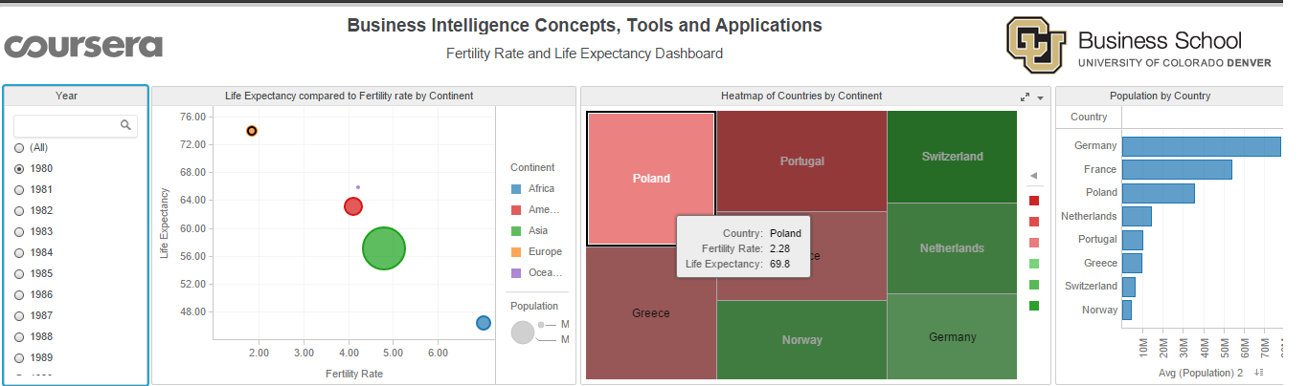

Poland has lowest fertility rate in 2007:

